WHAT IS 5-S?
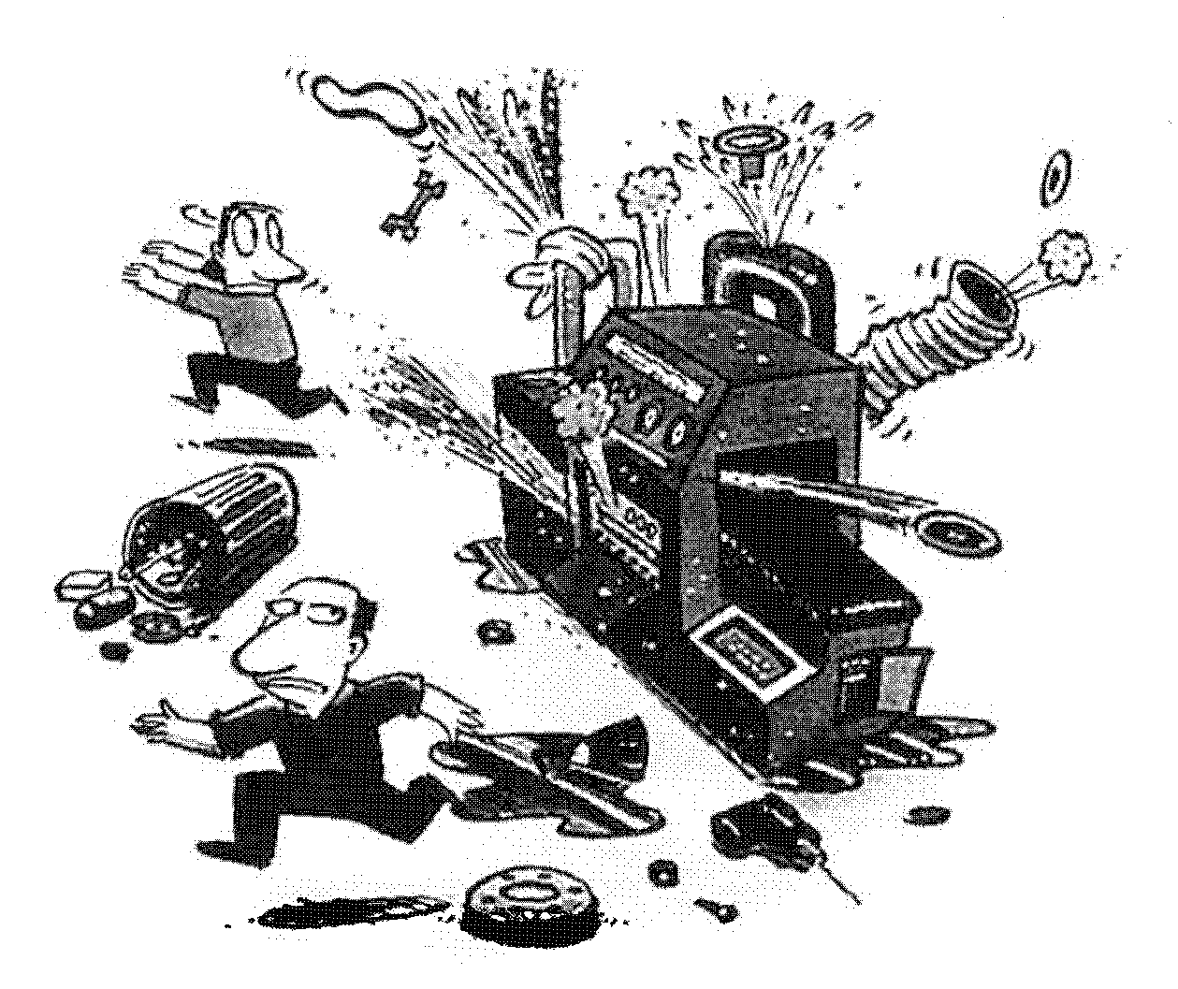

Sort

Set-In-Order

Shine

Standardize

Sustain

A factory that has not adopted the 5-S’s is dirty with oil, dirt, and chips. Parts and boxes are lying around in non-designated areas; high precision equipment is bought, but not maintained. When a jig or fixture is needed, it cannot be found. The morale of associates is poor and the plant is doomed for trouble.
PRESCRIPTION: Dose of 5S daily
Ingredients: Sort, Set-In-Order, Shine, Sustain, and Standardize
Effects: For all trouble symptoms.
Usage: No matter how long you take the 5-S remedy, it is very effective, and there are no side effects.
Caution: Once implemented, never discontinue improving

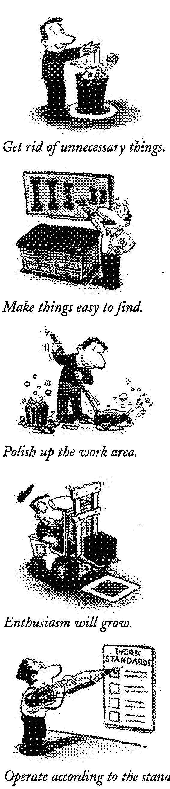
Here’s what 5-S means:
Sort
Separate what is needed and what is not needed, and keep only those things that are needed in the workplace. Discard unnecessary items.
THE MEANING OF 5S
Set-In-Order
Neatly place and identify needed work items. Designate a place for every thing so that anyone can find it. Always put things back in their designated spots.
Shine
Clean up. Always maintain a clean and shiny
work place. Identify why things are getting dirty.
Standardize
Become a role model for adhering to the standards of the first three S’s and encourage others to follow them. Make rules and procedures to promote a good work environment until the first three S’s become everybody’s second nature.
Sustain
Maintain and practice the first four S’s. Be thorough in straightening up, putting things in order and cleaning.
OK, what happens when the 5-S’s are used?
USING 5S
5-S is the Top Salesperson
- A Neat and Clean Facility impresses customers
- A Neat and Clean Facility wins more contracts
- A Neat and Clean Facility is more productive
- A Neat and Clean Facility produces fewer defects

5-S is Thrifty
• A Neat and Clean Facility is thrifty and economizes on everything

5-S is the Engine of Safety
• A Neat and Clean Facility is spacious, bright, visibly appealing
• A Neat and Clean Facility is a much safer place to work
  - Work areas and traffic areas are clearly marked
  - Hoses and electrical cords are not on the floor

5-S is a Timekeeper
• A Neat and Clean Facility meets deadlines better

5-S Promotes Standardization
• Better communication results in better understanding of plans and decisions
• Visual presentation of instructions is widespread
• Associates can easily perform most operations
• Quality and cost are stabilized with clearly communicated goals

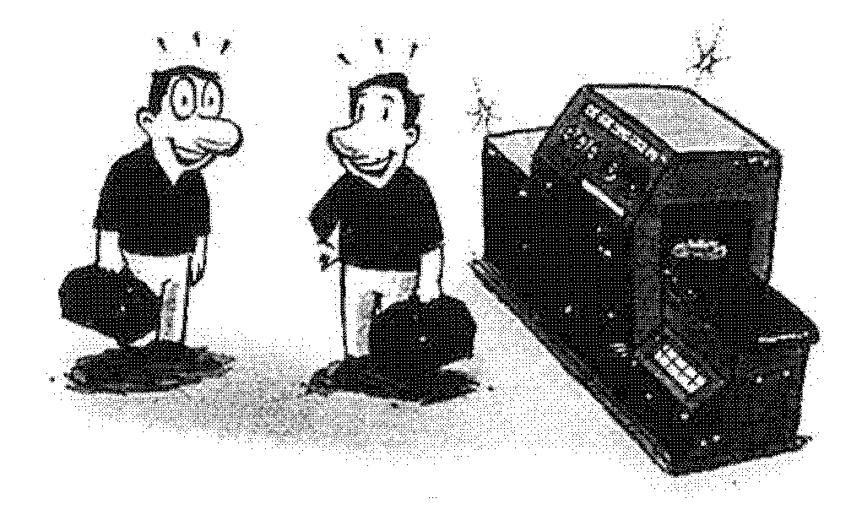
5-S creates an enjoyable workplace
• Fewer troubles in a bright, clean workplace.
• More involvement of associates and more ideas for improvement
• New ideas are quickly adopted
• There is a spirit of improvement in the plant.
• A Get-It-Done attitude is the rule.
PROMOTING THE 5S PROGRAM

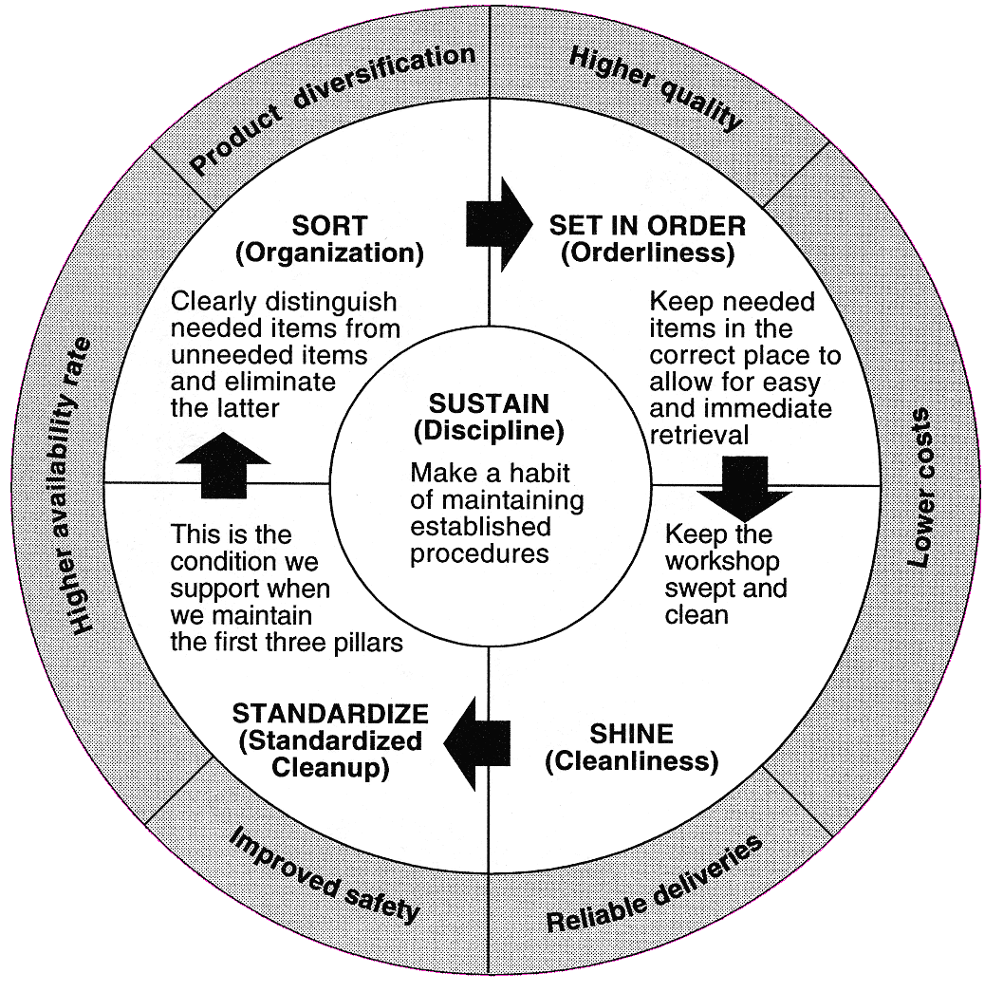

How do we implement a 5-S program?
PROMOTING THE 5-S PROGRAM
Step 1 – Align the organization to adopt 5-S
- Management and hourly associates participate
- Assign a 5-S champion devoted to the Lean Program
  - In charge of all 5-S education and promoting
  - Lead by example / Promote gradual implementation strategy and continuous improvement involving everyone
  - Declare the start of the 5-S movement
Step 2 – Schedule Kaizen Activities within individual workcells
- Initial Kaizen events should be conducted in areas with high impact, but fairly easy to implement
  - Sort - Conduct a Red Tagging Event
  - “Set In Order”- Organize Equipment, Tools, Parts and Materials
  - Shine – Make everything Spic and Span - Conduct a Cleaning Event
  - Standardize
    - Take Pictures of Before and After
    - Establish display and reporting boards
- Set aside 3 to 4 days for the event
- The work cell leader is the focus - get rid of unnecessary things
- Disposal of some items will be controlled by the management team
  - Valuable items
  - Items for which responsibility is unknown
  - Items which are used by multiple workcells
  - Items that are difficult to decide on
- List, prioritize, and implement improvements
  - Make a 5-minute announcement of improvements in the work area
  - Expect originality in each work area
Step 3 - Maintaining the 5-S workcell
  - Management audits results monthly
    - Workplace organization
    - Workcell documentation
    - Workcell Improvement
    - Public Commendation of superior work!
  - Management adopts and communicates best practices
  - Management adopts standards
  - Management makes extensive use of visual management techniques so that other work areas can imitate good ideas
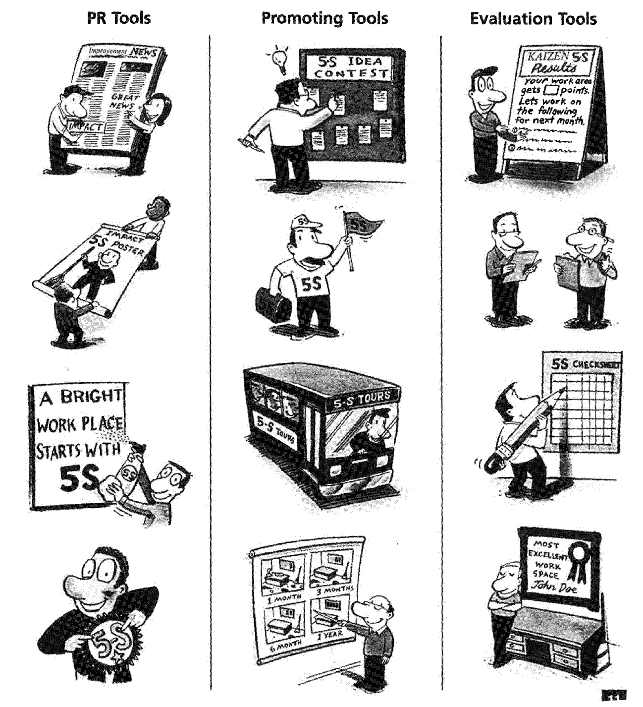
Meaning

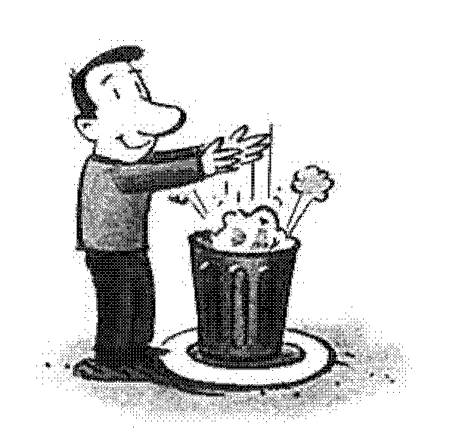
Sort: Separate what is needed and what is not needed, and keep only those things that are needed in the workplace. Discard unnecessary items.
Something used once a year would not be an everyday item. And we would not necessarily need all of the everyday items at once; but if lost, a replacement would be necessary.
The Key to Sorting
Sort does not mean that you throw out only items that you are sure you will never need. Nor does it mean that you arrange things into neat, straight patterns. When you sort, you leave only the bare essentials. When in doubt, throw it out!
Even after neatly arranging our tools, the proper tool can be difficult to find if we haven’t eliminated those which we don’t need. If we don’t get rid of things, we may not have room for the stuff we do need.
Before expanding, let’s think of organizing first!
We’ll be surprised at how spacious the plant becomes
SORT
Wastes Avoided by Implementing Sort
- Waste of Space, including shelves and cabinets
- Waste of inventory when parts and products become unusable and obsolete
- Waste of time in having to move things around and search for parts.
- Waste in control of unneeded items.
- Waste of time during inventory.
Method

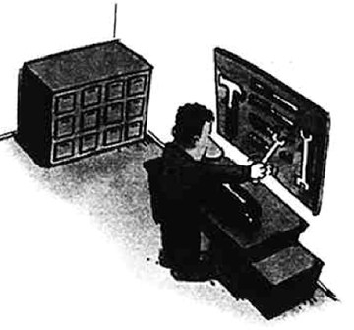Step 1 - Make a clear standard for deciding what is necessary
• Things used once in a day
Place close to area of use
• Things used once a week
Place close to the process
• Things used once in 2 months
Place close to the plant
• Things we don’t know if we’ll use
Place in a temporary storage
(If not used in one year, take further measures - throw away.)
• Things not used
Throw away
Step 2 – Choose a work area where success is sure; schedule a red tag event and have associates straighten up according to the standard
• Decide on the spot, implement on the spot
Step 3 – Audit Committee regularly checks for compliance
• Inspect frequently and without advance notice
• Evaluate the workplace; provide feedback to the associates regarding what is to be kept and what is to be discarded
Step 4 - Make sure that no unneeded things are brought into the plant.
• Do not create storage places for unneeded things.
• If it doesn’t have a storage place, we’ll know it’s unneeded.
SORT

Examples
SORT

We don’t need things we can’t use.
• Worn out gloves, sand paper, etc.
• Worn down drills, taps, and punches
• Inaccurate micrometers, calipers, and other measuring tools
• Jigs that can’t be used

Are rejects lined up with good parts?

• As soon as rejects are found, put them in the reject area.

• Remove defective parts from the work cell at the end of every shift

We don’t need things we don’t use
• Inventory, components of products not being made, or unfinished parts
• Old prototypes or samples
We don’t need a product we can’t sell
• Things whose design has become outdated.
• Things made in excess, due to mistaken expectations
• Things unable to be sold because they have rusted or rotted

We don’t need things that slow us down
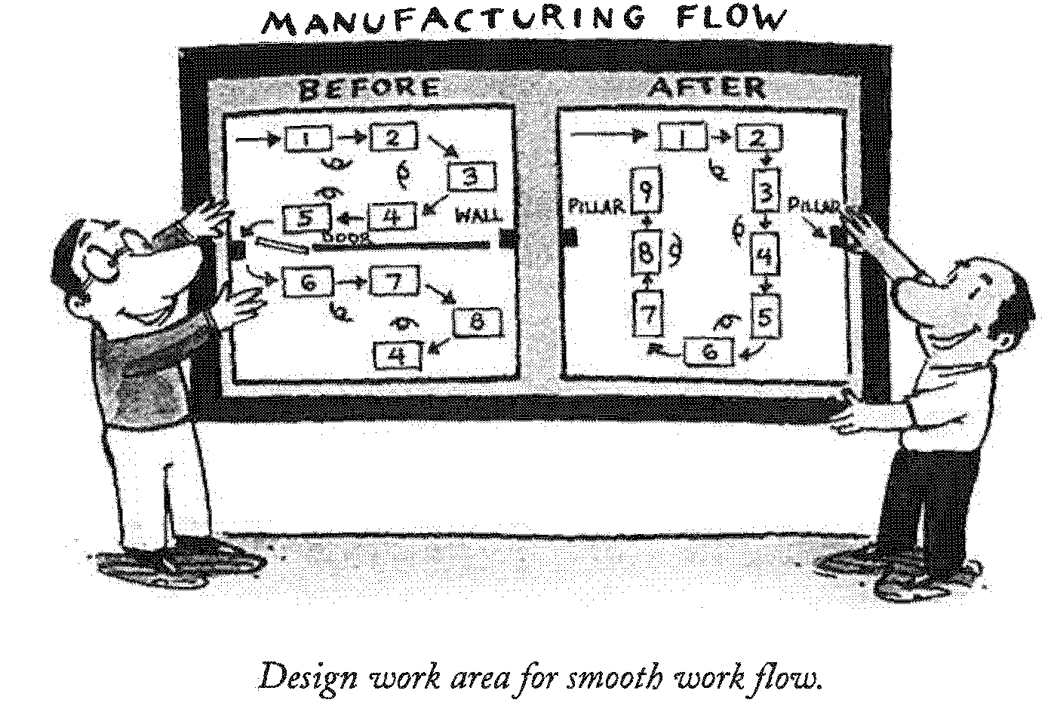
- Doors which must be opened or closed transporting products to the subsequent process?
- If structurally possible, consider removing the doors and walls
- Does the process add value?

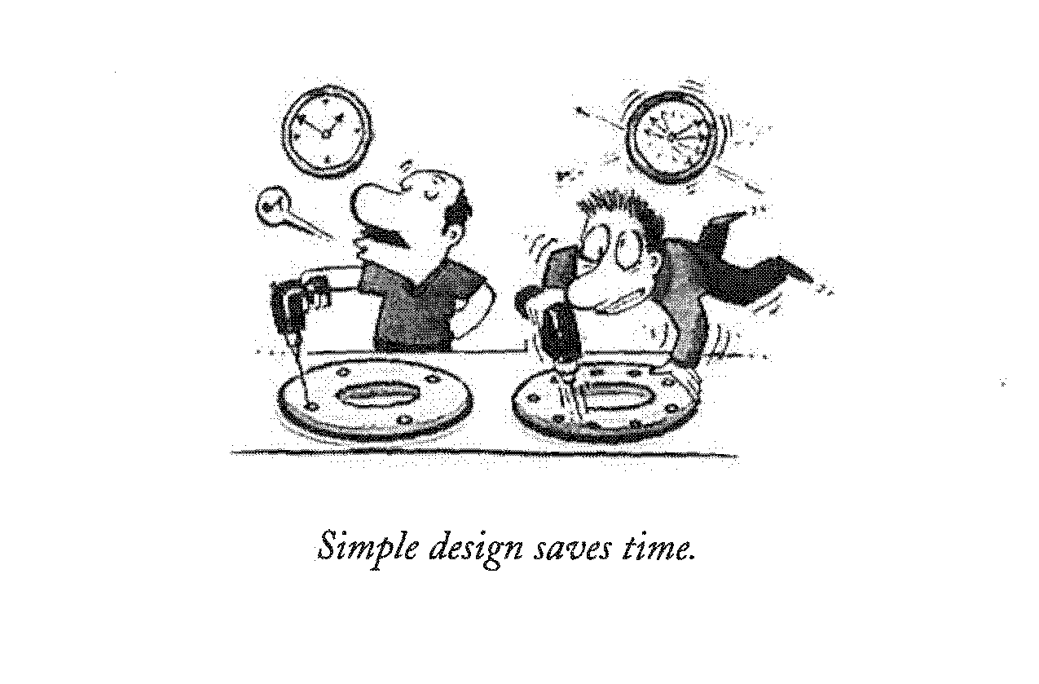
We don’t need an excess of assembly parts
• Have you ever thought, are those parts necessary?
• Assembly time can be compared to the number of bolts

The Red Tag Strategy is a simple method for identifying potentially unneeded items in the workcell, evaluating their usefulness, and dealing with them appropriately.
SORT

Red Tag Targets

Inventory
Equipment
Physical Areas

Raw Materials
Procured Parts
In-Process Inventory
Finished Parts

Machines
Jigs / Tools
Bits / Gauges
Tables, Computers
Floors
Shelves
Walkways
Operation Areas

 | Is the item needed every day?  Place close to area of use. |  |  | Do we know if we use the item or not? Place in temporary storage.
 | Is the item needed every week?  Place close to the process. |  |  | Is the item never used?  Throw away
 | Is the item need every couple of months?  Store away in a convenient place. |  |  | Stop bringing new, unneeded items into the workcell!

.
SET IN ORDER
Meaning

Set-In-Order:
- Neatly place and identify needed work items. Designate a place for every needed item so that anyone can find it
- Always put things back in their designated spots
- Make it so that new employees, people from other companies, or people who seldom come to the plant can find things easily
- Design a storage place that is well marked so that necessary items can be taken out quickly and used easily
- Create storage space that makes it easy to return things to their
places and see if they’re missing
- If things are in order, time wasted due to searching is eliminated.
Wastes Avoided by Implementing Set-In-Order
- Waste of time searching for parts or tools
- Waste from stopping the process
- Waste from replacing lost items
- Waste caused from changing plans
- Waste from late deliveries

Meaning

Step 1 - Straighten up thoroughly
- Never straighten up anything you do not need; just get rid of it
- Within the work area, store only the necessary minimum
- Decide whether each item is a personal possession or a group possession
Step 2 - Decide on where to place things
- Decide on a convenient place in the work area to place things
- The more it’s used, the closer to the process you place it
Step 3 - Decide on how to place things
- There are many different ways of storing things such as: shelves, boxes, lockers, and hanging. Storage should display items clearly for easy identification and access. We welcome any ideas from each work area.
According to function: storage places for objects with the same function
According to product: organizing a set of objects necessary for a certain product and placing them in one container or location.

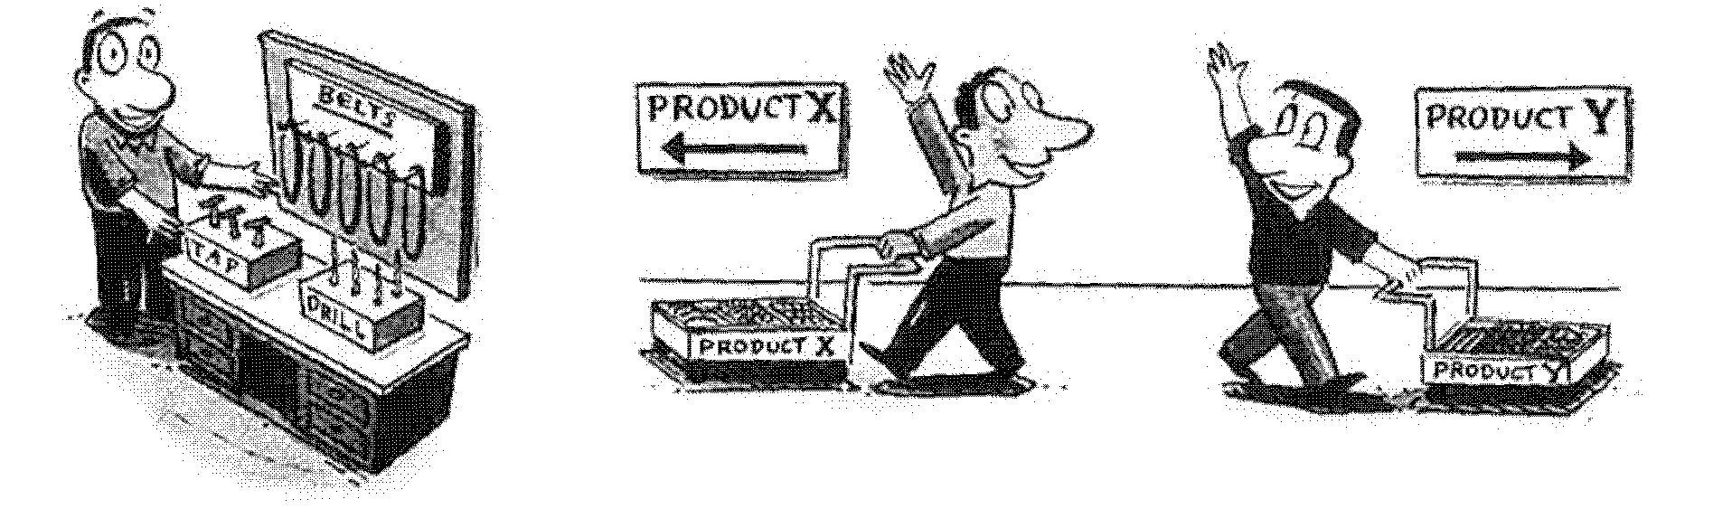
SET IN ORDER

Step 4 - Display
SET IN ORDER
- Locate display in the storage area
- Display the actual item to be stored
- Label and identify the storage location of each item
- Sign-out sheets can be used to keep track of items

SET IN ORDER
Examples

Put things so that anyone can find them
- Post a list of articles (names, pictures)
- Make things easy to take out. Even a nicely made tool board can make things hard to take out or even cause an injury if it’s too crowded. So, leave plenty of room.
- Enter the name of the person who is responsible for the articles.
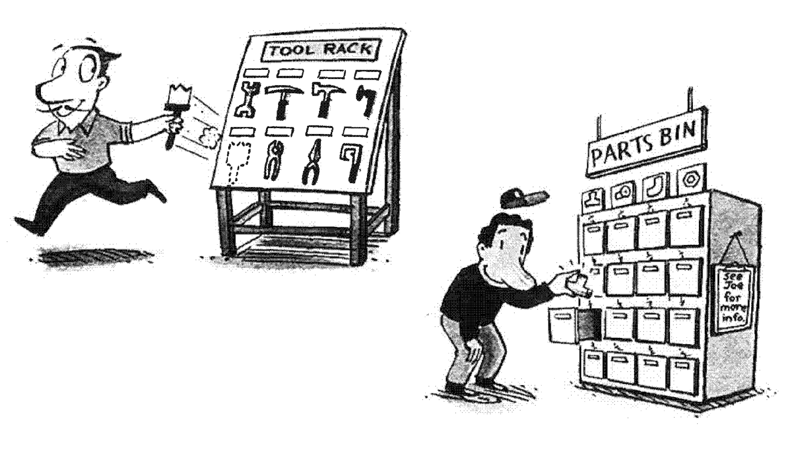

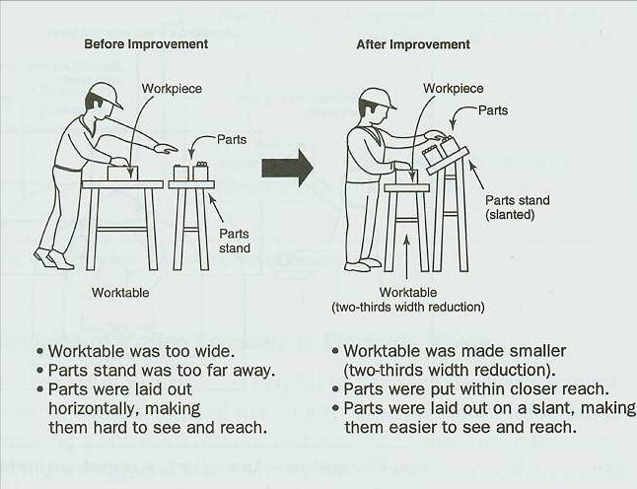

Arrange Equipment for easy access to parts by operator

Examples
SET IN ORDER
Examples

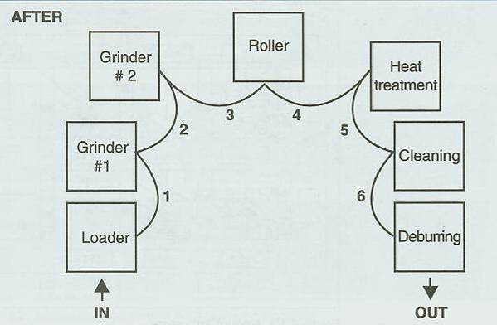
Arrange equipment to allow flow production

Standardize by taking pictures, drawing sketches, and marking floor so everyone knows where the equipment belongs.
- Use shadow boards to standardize location of hand tools
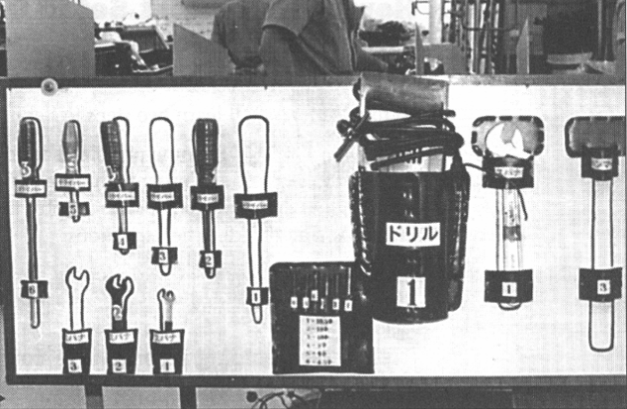
- Place Shadow boards for easy access of tools by operator
- Mark addresses on both racks and totes
- Designate location and label it for all materials
- Use bins as signals for production when possible
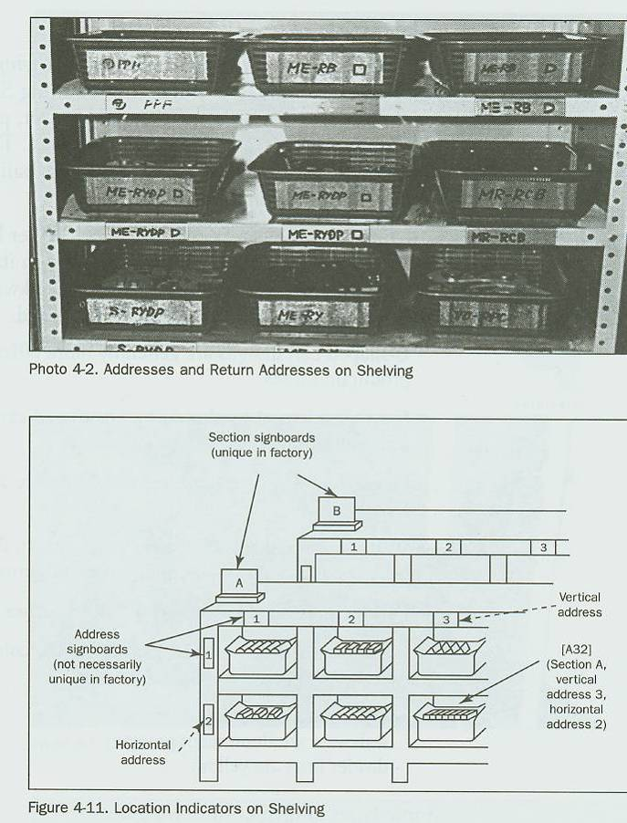

Here’s how to store parts and in-process inventory
SET IN ORDER
- Place parts according to kind, and make the amount easily seen
- Make first in, first out possible
- Make the area only big enough for the necessary amount
- Make it so that when there are too many parts, they protrude from the area. This way anything abnormal can be discovered
- After everything’s put in order, post written standards in the area and train everyone in the workplace

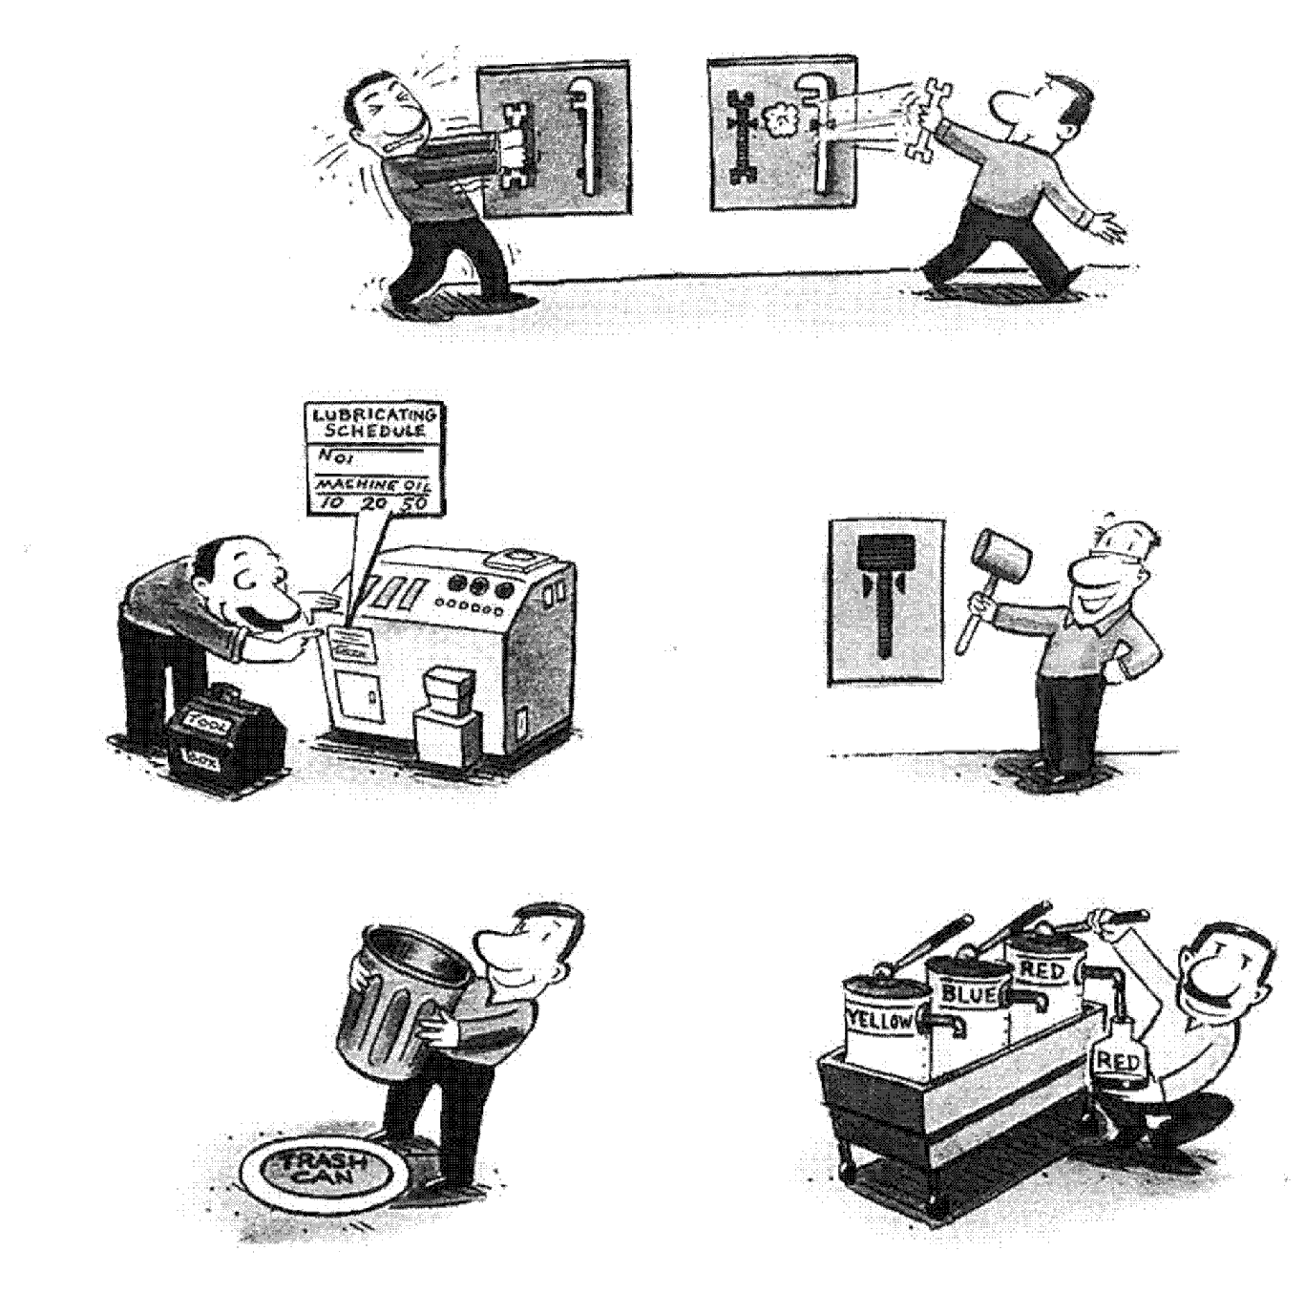

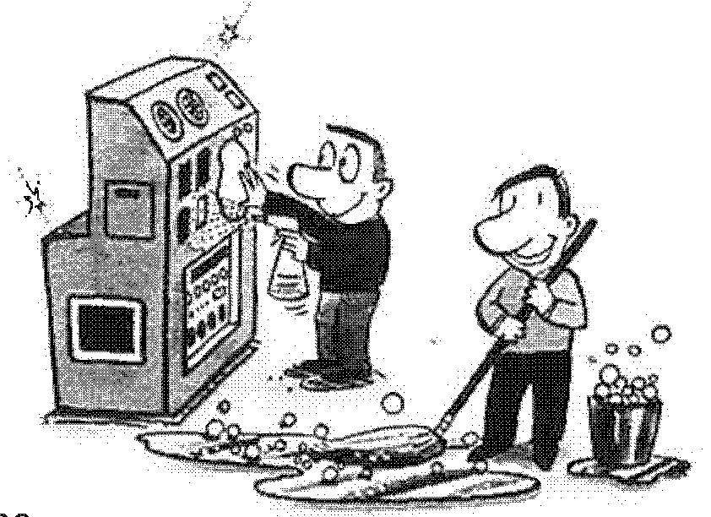
Shine: Clean with a purpose and always maintain a clean and shiny work place.
SHINE
Meaning
Even if you straighten up, put things in order, and arrange necessary items so they can easily be taken out, it’s not enough unless the object taken out is in a usable condition.
Ensuring equipment is in usable condition is the primary purpose of shine.
- Get rid of all garbage and dust from the work area
- Clean everything from the floor, the walls, the ceiling, and even the opposite side of the fluorescent lights or the inside of cabinets
- All machine equipment, shelves and lockers also must be cleaned
- Especially today, since high quality and high value added products are being developed and produced, even a small amount of dirt or dust can cause rejects. No matter how advanced the machines are, if they are not being cleaned thoroughly, it won’t mean a thing. Cleaning up (Shine) does not mean just to clean; it should be recognized as a vital part of the manufacturing process
- Polish the machinery every day so that our equipment really shines
- Never just paint over the dirt on machines. Don’t mistakenly think that if it looks clean, it is clean.
- Thoroughly polishing the machines and equipment every day will allow any little abnormalities to be discovered. This is called a clean-up examination.

SHINE
Method

Step 1 - First, get rid of all that dirt
- Use the top down cleaning method – clean from the ceiling to the floor
- Clean thoroughly with a broom, mop, and a dust cloth
- Make sure that the office staff and the leaders participate.
They should use the brooms, too!
Step 2 - Correct any issues uncovered by cleaning up
- A bumpy floor makes transport difficult, it scratches the
products, and is not safe
- Is there any trouble with any of the machinery?

Step 3 - Pinpoint the root cause of dirt and cut it off at the source.
- Are you cleaning every day, but are still unable to keep things clean?
- Pinpoint the root source of the dirt and take corrective measures so that dirt does not occur
- Conduct a Kaizen project with local operators to locate the root cause of the dirt; decide how to prevent it and keep the areas clean.
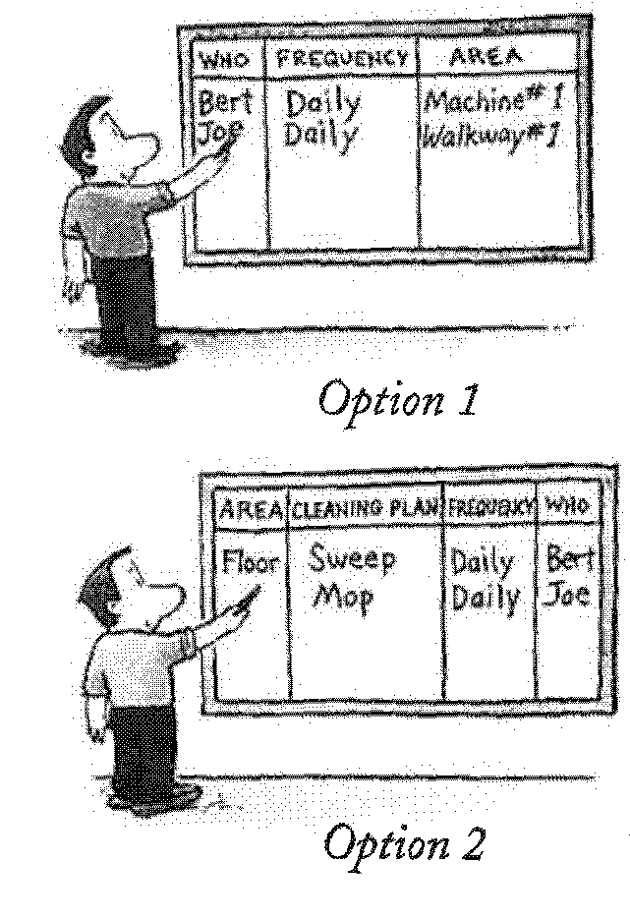
Step 4 - Make up a standard cleaning chart with areas and responsibility assigned and implemented every day without fail

SHINE
Examples

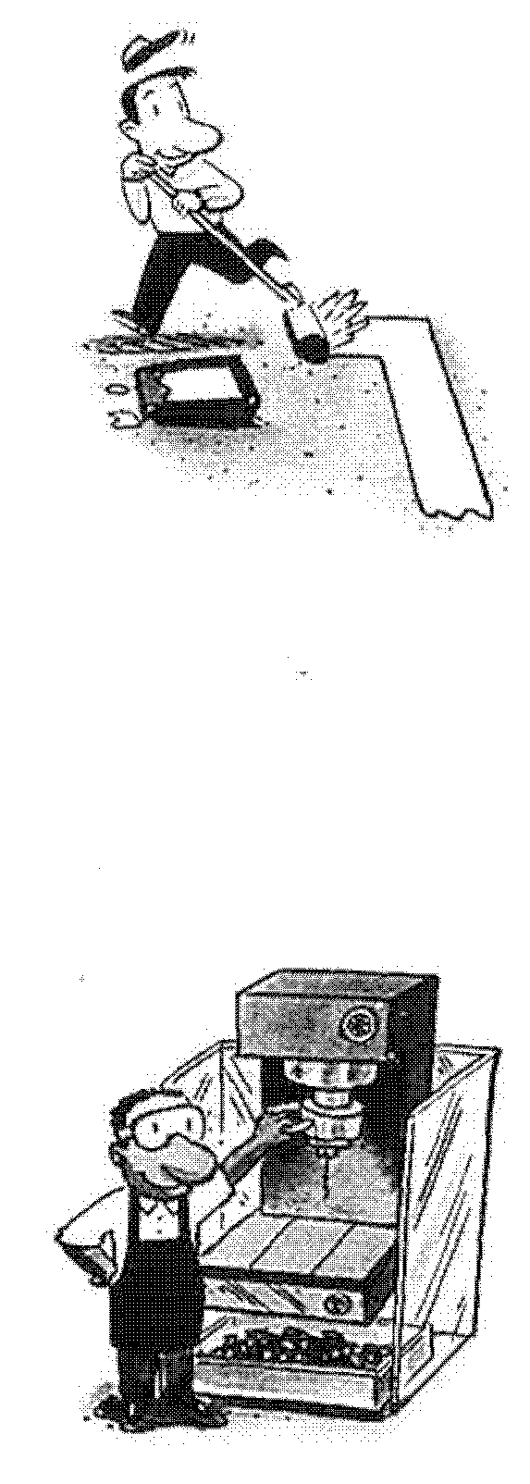
First, start with some Shine (cleaning) tools
- Are there any dirty dust cloths or mops hanging up?
- Are there any brooms that can’t be used?
- Also, manage brooms and mops by keeping a certain fixed number of them
During periods of work stoppage, everyone can help make our area shine. A first stage starts with deciding on boundary lines.
- Borderlines on the floor are distinct
- Boundary lines on the floor organize traffic within the plant
- Things are at right angles and parallel
- Nothing is to be placed on the line
- Redraw faded lines. Faded or dirty lines are a source of accidents and are dangerous
Make sure product chips and scrap don’t scatter out from the process
- Don’t leave scattered bits of material lying around
- Scraps left lying can pierce an associate’s or customer’s shoe
- Use trays or tables to catch chips or scrap
Make it clear who is responsible
- Everyone knows his or her responsibility.
- Conduct a morning meeting and designate an owner

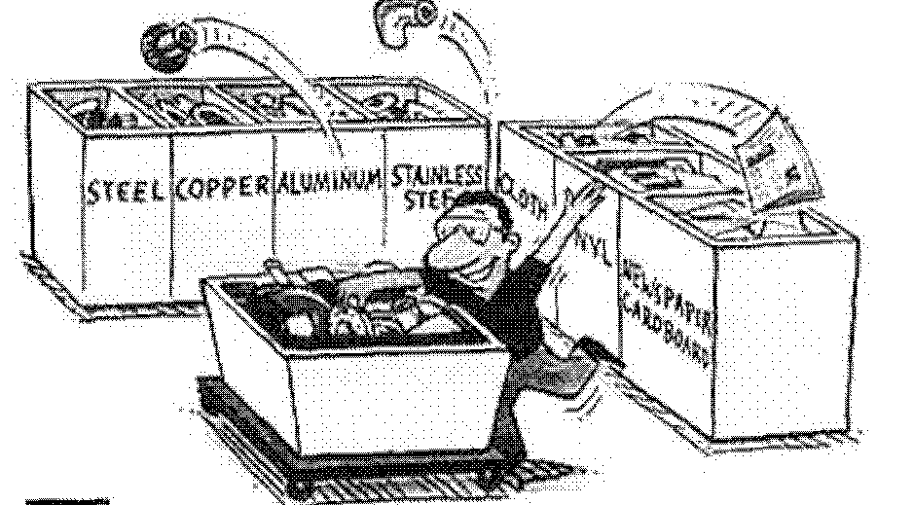

SHINE: Total Equipment Management

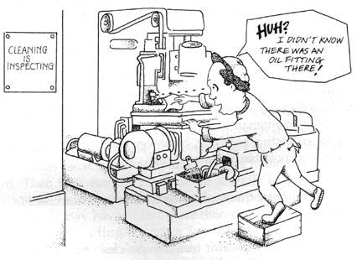

Step 1: Initial Cleaning

Thoroughly remove debris and contaminants from the equipment and remove unused equipment parts.
- Eliminate causes of deterioration such as dirt and dust
- Discover and treat hidden defects – document all identified issues with the equipment which cannot be immediately repaired.
- Paint the equipment so that future issues with the equipment can be quickly identified.

Step 2: Eliminate Contamination Sources and Inaccessible Areas

Eliminate the sources / causes of the dirt and debris and make it easier for ongoing cleaning and lubrication.
SHINE: Total Equipment Management
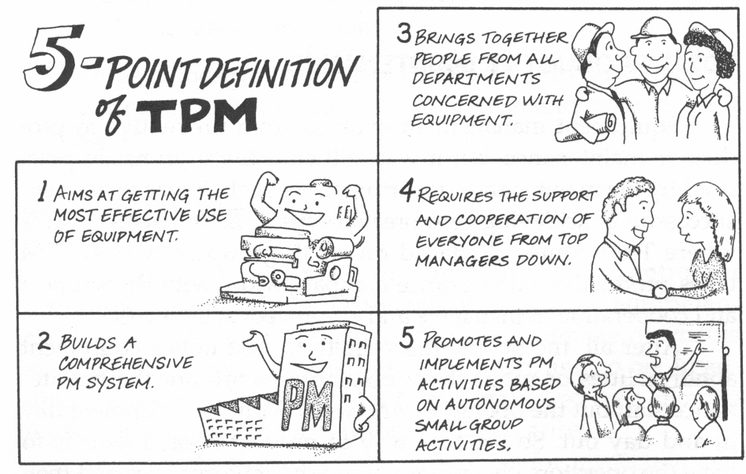

5 Pillars of TPM

- Improvement Activities designed to improve equipment effectiveness
Breakdowns
Setup / Adjustment
Idling and Minor Stoppages
Speed
Quality Defects and Reworks
Start Up Losses

  - Eliminate the 6 big equipment losses

Autonomous Maintenance Program to be performed by equipment operators
How much time do you lose due to equipment breakdowns?
Do you ever “know” when your machine is about to fail?
Do you think your machines are easy or hard to setup? Could they be made easier?
- A Planned Maintenance system
- Training to improve operation and maintenance skills
- A system for Maintenance Prevention and early equipment management

Meaning

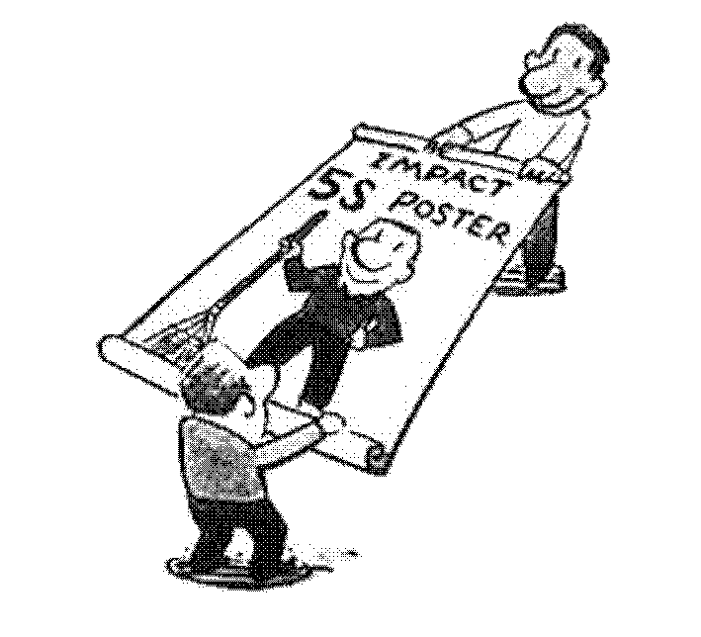


Standardize: Become a role model for adhering to the standards of the first three S’s and encourage others to follow them. Make rules and procedures to promote a good work environment until the first three S’s become everybody’s second nature.
STANDARDIZE
- Once the need to standardize becomes part of the culture of our workplace, everyone in the plant will have the discipline to follow through on what has been decided.
- Some people may say;
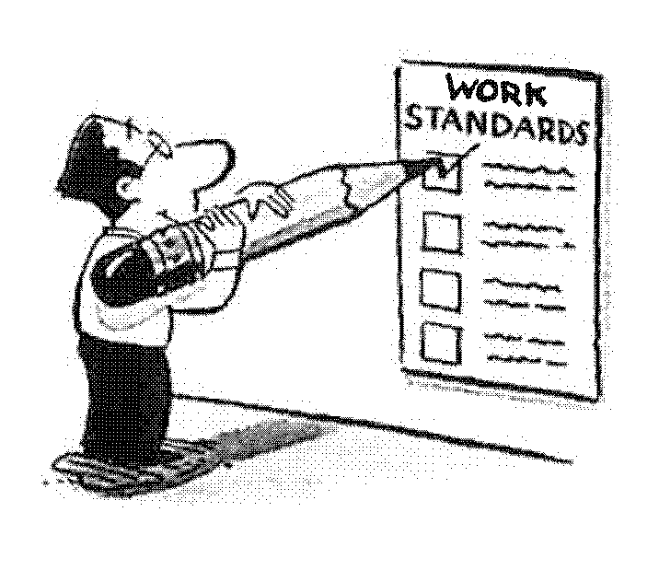
“Even if our company does the 5-5, it will never work because the basics of the job are not even being done”
“Even if we make a tool board, no one returns things to where they belong.”
“Even if we decide on a place to put parts, it is only followed for the first two or three days!”

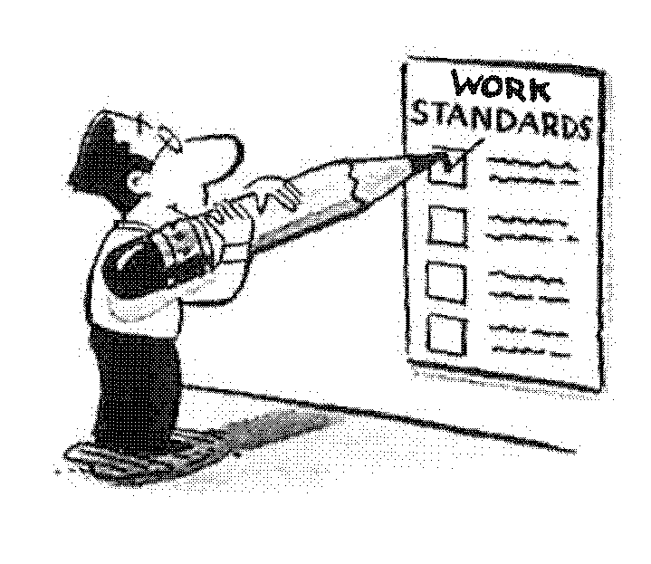
If we consistently use the first three S’s — Sort, Set-In-Order, and Shine; we will find it easy to standardize our work methods and continuously improve our efficiency and productivity. We will follow through on planned procedures each and every time.
By having standardized methods in place, we will be able to adapt more easily to changing conditions and be ready to take on new, complex challenges in the future, Over time, the merits of the 5-S’s will become part of every aspect of our work.
Meaning
STANDARDIZE

- Design
STANDARDIZE
I will design a product that has been decided, in the way that it has been decided, on the day that it has been decided.
- Production Work Place
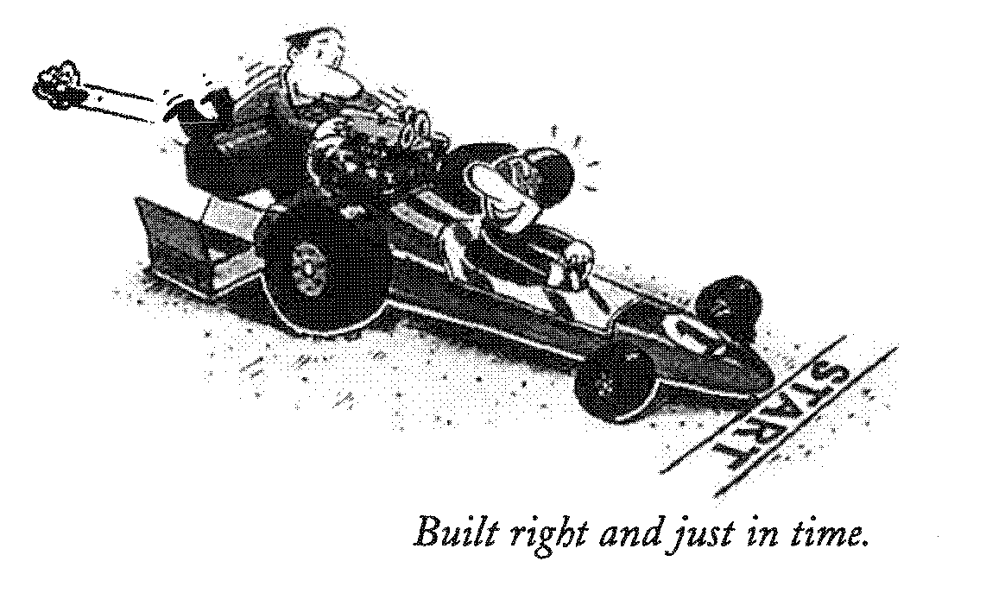
I process the designated material, with the designated machine, following the pre-determined methods.
  - Materials
I procure the decided materials, on
the designated day, at the decided price.
• Shipping
I deliver the designated product on the decided
shipping date to the designated place.
• Process Management
I do the production and manpower plan by the decided delivery
date, following the decided rules.
Many times things are not put back in place because a proper organized place has not been decided. (They can’t be put back in their proper place). We must properly decide how to organize the work cell so that we have a standard to judge against.
  - There should be no reason for rejects
  - Costs should decrease
  - There should be no late deliveries.
We may not understand difficult things like QC or industrial engineering, but we are doing things just the way they have been decided.
SUSTAIN
Self Discipline:
Maintain and practice the
first four S’s. Be thorough
in straightening up, putting
things in order and cleaning.
Once you start the 5S’s do not let them fade out
halfway through and come to nothing. The cycle of starting out strong and then losing enthusiasm causes people to resist change and therefore to resist improvement that is essential to our future. When this occurs the company tends to fall into a rut.
SUSTAIN
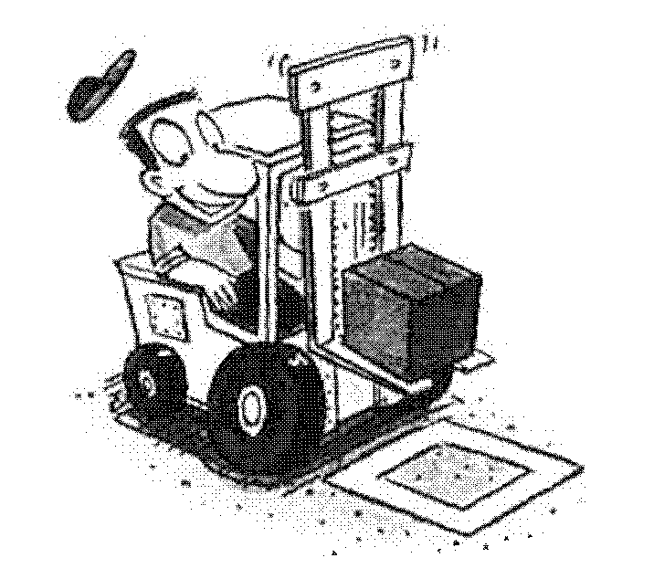

Meaning

“No matter what our company does, we leave things half finished.”
“I wonder if the 5-S program is just another flash in the pan like the Such and Such program?”
“After all, no one will follow it anyway”
“Well, let’s just get it over with”

The best way to overcome this type of thinking is to break the cycle and really devote ourselves to the continuous improvement program and 5-S approach. We can all work together and make this a successful way of conducting our day-to-day business.

Meaning

Step 1 - Maintain 5-S awareness
SUSTAIN
- We need to be continually motivated to improve the company and promote the 5-S program.
- Distribute a 5-S newsletter, 5-S posters, 5-S awards, 5-S motto, 5-S Day — always continuing to inspire fresh, new enthusiasm
- Develop a trigger for implementing Improvement activities

Step 2 - Create opportunities to improve the 5-S
- Group tools to use are:
  - 5-S observation tours
  - Continuing Kaizen workshops
  - Team and Management Audits using Workplace Organization Tool
  - Team and Management Audits using Cleaning and Lubrication Standards and Visual Work Instructions

Step 3 - Create motivation for 5-S
- Motivation at the workshop level
- To what level has our company progressed in the 5-S program? What is our goal?
- Promote the idea of how much more the 5-S level of the company as a whole needs to improve to pass our competitors
- Take a video/pictures of our area every 6 months and compare to see improvements.

PROCEDURES: SORT
Step 1 - First, we decide things together
- Everyone makes decisions together regarding the work area
- Design or “plan-how” meetings are held
- Utilize Visual Management methods to communicate

Step 2 - Present things that have been decided so that anyone can understand them
- Not so that they have to read to understand, but so they can see and understand
- Make it so that anyone can understand within ten seconds

Step 3 - Point out immediately when things are not being implemented as decided
- Raises issues on the spot
- Don’t be shy, because we’re all doing this together
- Focus on facts, not on personalities

Step 4 - Anything that has been pointed out, revise immediately
- Excuses such as “Well, we’re right in the middle of operations” are not acceptable

Step 5 - Repeat steps one to four times as many times as necessary
- The frequency of meetings is more important than their duration
- Sitting is not necessary; standing is fine for meetings.
Examples

Let’s look at one day’s work;
PROCEDURES: SORT
Every morning have a 5 minute meeting before starting work
- Cheerful and ready to work
- With all tools and proper gear
- Everyone sharing information

As soon as the morning meeting is over, go to work stations.
- Confirm today’s job
- Check materials and machines per startup procedure
- Don’t forget safety procedures and protective gear
Operation begins at the designated time
- With the designated material
- Using the designated machines
- Following the designated methods
5-S matters at break and lunch
- After the bell goes off, wash up for break
- Clean up your break area afterwards
- Breaks are taken at the designated time in the
designated place
- After break or lunch, return to your work position promptly
Clean up before going home
- Confirm tomorrow’s plan
- Parts and materials are arranged in order
- Everything is turned off that should be turned off
- And last of all, a cheerful “See you later.”
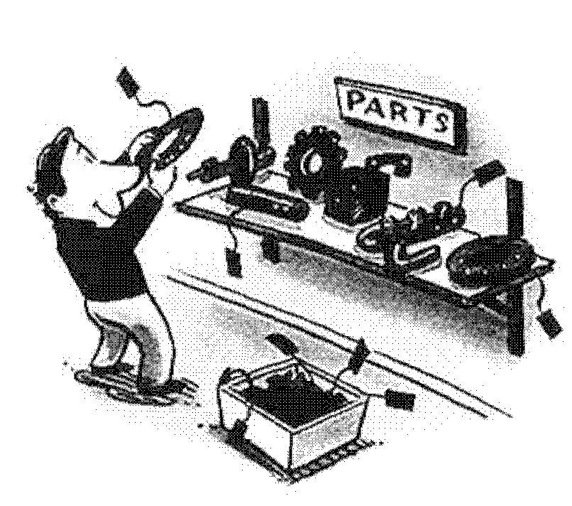
PROCEDURES: SORT
Removing All Unnecessary Items – Red Tag Activity

Sort does not mean that you throw out only items that you are sure you will never need. Nor does it mean that you arrange things into neat, straight patterns. When you sort, you leave only the bare essentials. When in doubt, throw it out!

Procedure

1 The Key to Sorting - Wastes Avoided by Implementing Sort
- Waste of Space, including shelves and cabinets
- Parts and Products become unusable and obsolete
- Waste of time in having to move things around & search for parts
- Waste in control of unneeded items
- Waste of time during inventory
- Decide which objects need red tags attached
- Inventory, machinery, and facilities are subject to scrutiny
- Decide on rules for red tags / Attach Red Tags
- Objects not used for over one month
- Tags should be attached by associates involved in process
- Red tag everything suspected of being unnecessary
4 Confirm if object was used (over a period of one month). If used, remove the tag
5 Dispose of objects with red tags attached
- Classify into defective items, dead stock, and non-circulating items and dispose
- Red tag inventory: Defects, Dead Stock => Dispose,
Non-circulating items = Move to other section or dispose

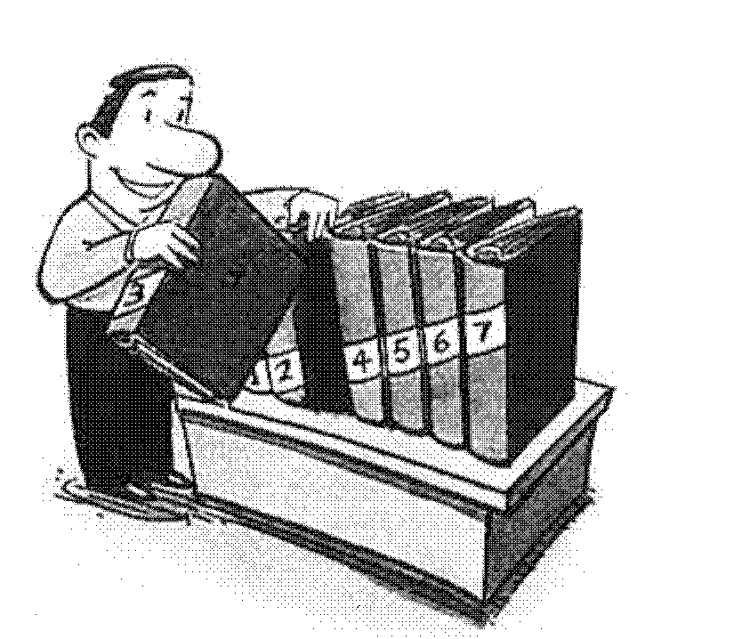
PROCEDURES: SET-IN-ORDER

Promoting SET IN ORDER inside Cabinets

Arrange items in cabinets so they can be removed quickly and easily when needed

Procedure

1 Decide quantity and location of items to be stored in the cabinet.
- Frequently used items are placed close and at an easily reached height.
- Arrange by function or process.

2 Determine the placement method so it can be easily seen if an item is in place.
- If the returning task is helped by using different shapes, use a base plate with matching shapes.
- On files, file number is written diagonally.
3 Clarify contents of cabinets with labels on the outside of the door.
- If stored in boxes, identify contents of each box.
PROCEDURES: SET-IN-ORDER
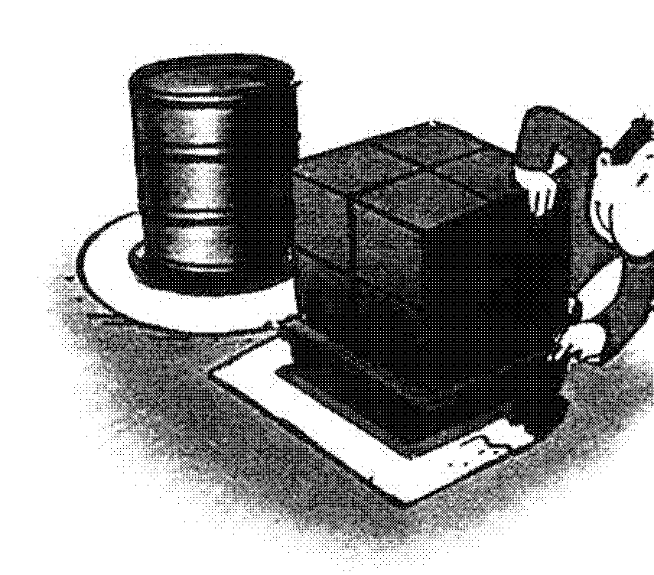
Clarifying Location for Part Shelves and Chutes

Clearly identify the location of parts
shelves and chutes so parts are easily
and efficiently accessible.

Procedure

- Prepare paint or tape
- Fixed position—use paint.
- Flexible position—use tape
- White – Production area
- Red – Nonconforming material or tools
- Green – WIP or replenishment
- Blue – Equipment
- Yellow – Safety or Caution
2 Use the following marking methods:
- Indicate rectangular items with rectangles
- Indicate circular items with circles
- Priority on easily moved objects.
- Lines must be uniform and straight
- Lines to be parallel or at right angles to aisles (except for ease
or to improve efficient operation)
3 Ends of shelves and chutes should be inside the lines
- The front of chute should be inside the line.
- Objects should not protrude over the line
4 Maintain the lines
- If lines get erased, repair them.

1. Set-In-Order: Toolboxes
PROCEDURES: SET-IN-ORDER
- Place toolboxes as close as possible to the point of use
  - Decide on a convenient place in the work area to place tools
  - The more it’s used, the closer to the process you place it
- Designate a place for every needed tool so anyone can find it

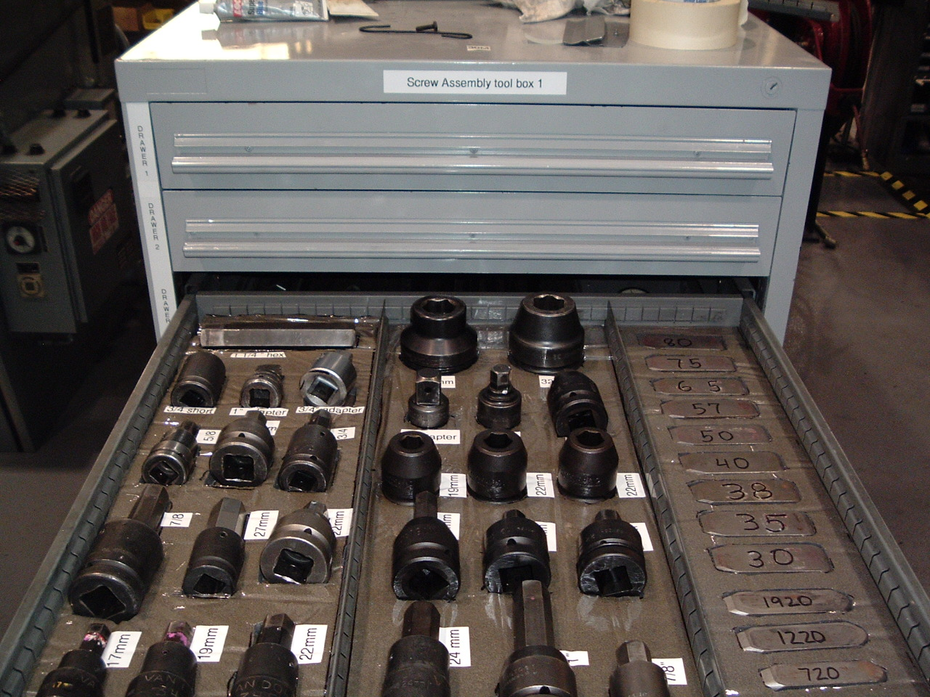

- Label the location with the tool number / type.

- If practical, label the tool as well

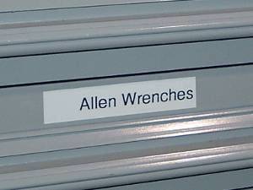
- If the tools are in closed or locked toolbox, label the drawers too!
- Always return tools to their designated spots
- Assign responsibility for ensuring that tools are returned and toolboxes are locked at the end of each shift
- Create a template / overlay to assist in inventorying tools

PROCEDURES: SHINE
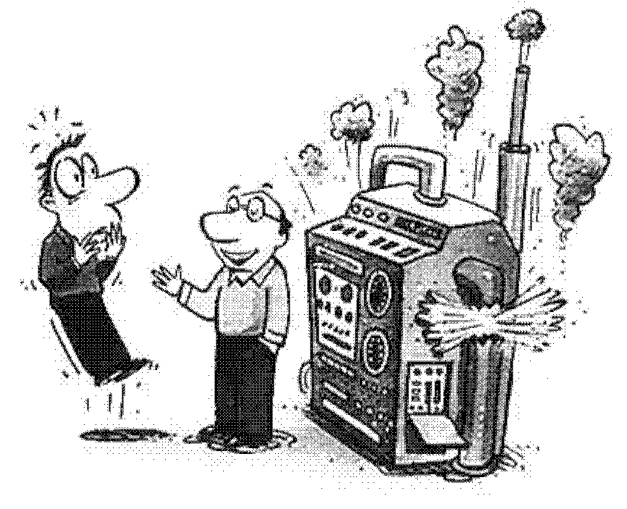

Preventing Objects from getting broken by being left unattended

Broken items are repaired immediately or replaced with new items

Procedure

1 When items are broken on the shop floor, operators should be instructed to report to their supervisors immediately.
- Explain at every opportunity the need to alert supervisors and make them aware of the broken items.

- Allocate responsibilities to each operator and hold them accountable for any defects or failures within that area.
- Allocate everyone an area centered around his or her work area until the entire group has been covered.

- Supervisors should audit this procedure once a week. Address any violations.
- This must be maintained.

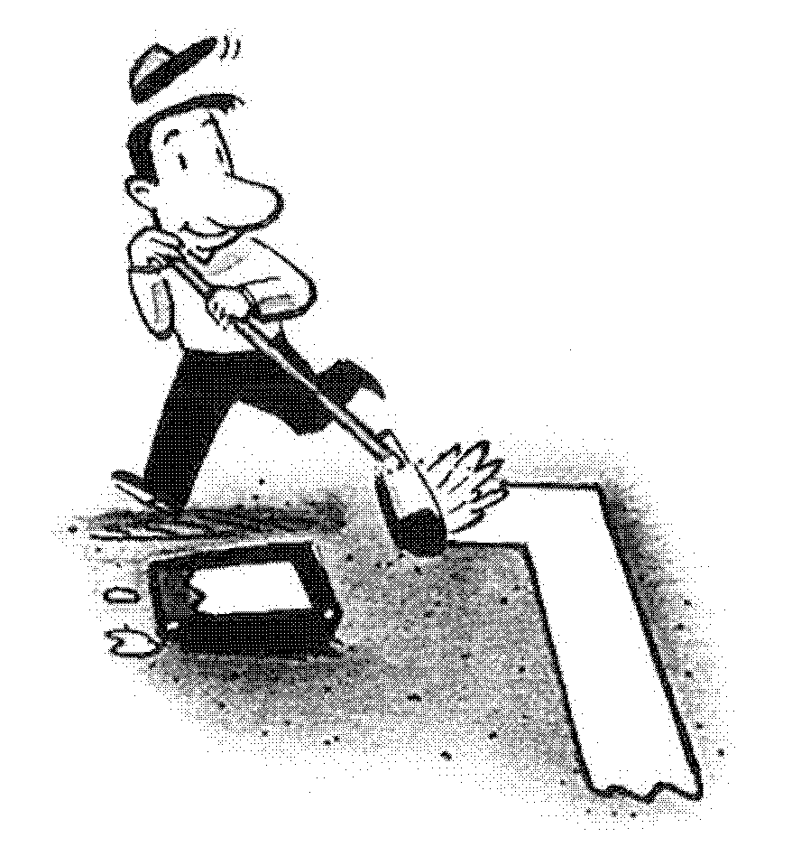

PROCEDURES: SHINE

Identifying Work Areas (Painting or Taping Lines)

By painting or taping white or yellow lines, the entire plant is to be divided into:
- Work Area
- Aisle Area
- Parts Area

Procedure

1 Decide on areas of work, aisle, and parts storage

2 Draw white or yellow lines
- Line width to be 100 mm, or 4 inches.
- Drawn straight from one end to the other

3 Edges of chutes, carts, parts, and other items to remain
within the lines
- The front of chute should be inside the lines
- Objects should not protrude over the line
- Empty boxes, cart hooks, and waste bins should be inside the lines

4 Maintain the lines
  - If lines get erased, repaint or re-tape them
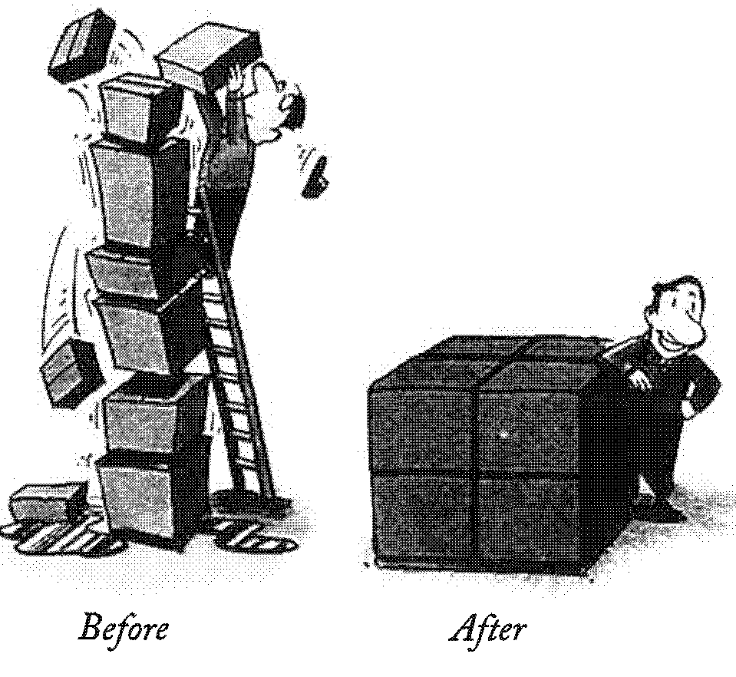
PROCEDURES: SHINE

Maintaining Operations without objects being dropped, leaking, and getting dirty

Keep areas clean and orderly and a state of cleanliness will be maintained.

Procedure

- Have a “cleanup” day when everyone takes part in “spring” cleaning
  - Target aisles, rest areas, and other common use areas.
(Example: aisles will be cleaned after lunch on Fridays.)
- Allocate an area to each operator and hold him or her responsible for cleaning within that area
- Allocated area should be in each operator’s own work area, so each has equal work
- Post responsibilities on the group’s notice board
- Set up a standard Shine work schedule to be conducted 5 minutes each day
- Eliminate sources of dust and dirt. For places that need continuous cleaning, determine causes and fix (See 5-S examples)
- Analyze the causes
- Refer to good examples in other locations
- Make a chart of difficult locations to prevent oversight.

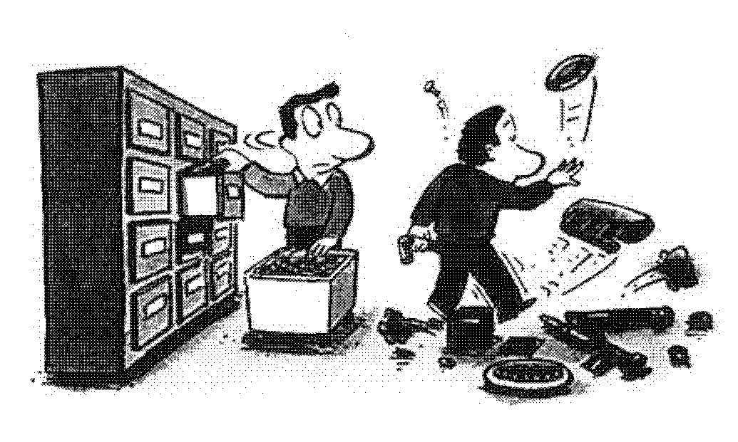
PROCEDURES: SHINE

Ensuring Everyone’s Participation

Once an area has been improved, it is important to have compliance by everyone

Procedure

1 Make certain what has been decided is communicated to every person concerned
- Explain at every morning meeting
- Have everyone caution people who are not complying with directions
- Supervisors should audit this procedure once a week, checking for noncompliance
- Follow Up to prevent recurrence
- Set a schedule to be followed at all times
(Example: every Tuesday at 1:00 p.m.)
- Pursue causes of “non-conformance”
3 Exercise ingenuity so items can be put away in an orderly fashion. (See specific examples of Set-In-Order)
  - Flexibility in accepting and following good examples of others
  - Closely observe other shop floors for hints
  - Encourage operators to give their efforts and ideas

1. Workplace Organization (5-S)
Category | Valuation Factors |  |  | Valuation Comments | Valuation Rating
 | 1 | 6 | 10
Safety | Unsafe, many hazards, policies loosely enforced, local ordinances violated | Moderately safe. Few hazards, policies enforced somewhat, general local compliance | Very safe, no hazards, rigid adherence to policies, full local compliance
Lighting / Brightness | Poorly lit, dingy, looks like a cave, no fresh paint | Moderately lit, some fresh paint in offices, ceilings, walls, machines, floor | Brightly lit, freshly painted floors, ceilings, offices, machines and walls
Cleanliness | Very dirty, floors not clean, dust / oil on machines, desks and chairs dirty | Generally clean, floors, offices, machines somewhat clean, some end of shift cleaning | Offices / factory immaculate, no dust and oil on machines, floors free of debris
Order | Very cluttered, lots of junk in aisles and work areas, desks and cabinets disorganized | Some training at associate level | Only critical items on shop floor, offices and work areas clear, marking on floor and use of shadow boards
Overall | Pig Sty | OK, but not great | Looks like a hospital

Red Tag
Category |  | - Raw Material  - In Process Stock  - Semi Finished Goods  - Finished Good  - Equipment |  |  | - Dies and Jigs  - Tools and Supplies  - Measuring Devices  - Documents  - Other
Item Name and Number

Quantity |  | Units |  |  | $ Value
Reason |  | - Not Needed  - Defective  - Not Needed Soon |  |  | - Scrap Material  - Use Unknown  - Other
Disposal By |  | Department / Business Unit / Product Center
Posting Date |  |  |  | Disposal Date
 | Red Tag
 | Category |  | - Raw Material  - In Process Stock  - Semi Finished Goods  - Finished Good  - Equipment |  |  |  | - Dies and Jigs  - Tools and Supplies  - Measuring Devices  - Documents  - Other
 | Item Name and Number
 | Quantity |  | Units |  |  |  | $ Value
 | Reason |  | - Not Needed  - Defective  - Not Needed Soon |  |  |  | - Scrap Material  - Use Unknown  - Other
 | Disposal By |  | Department / Business Unit / Product Center
 | Posting Date |  |  |  |  | Disposal Date

